A brief version of the purpose of your study, followed briefly by what you did and what you found.

*Keywords:*

Mood, words recalled, music, word list, encoding, retrieval, mood-dependent memory, MDM

The Impact of Music on the Mood Dependent Memory Effect

Mood and memory connections have been studied in many ways. The effect of music on mood and how music may enhance memory has been one area of particular interest. The mood state at the time of encoding information predicts better recall of mood congruent stimuli, both positive and negative. Mood altered by music has many significant effects on cognitive processes and different types of memory tasks. This includes visuospatial tasks (Palmiero, Nori, Rogolino, D'Amico, & Piccardi, 2015), music recall tasks (Houston & Haddock, 2007) and different types of word recall tasks (Balch, Myers, & Papotto, 1999). If music can be used to increase positive mood and assist in performance of memory tasks, this could enhance the way that people learn.

Houston and Haddock (2007) explored the effects of music on mood to increase memory. The researchers hypothesized that an individual in either a positive or negative mood would show an increased ability to recognize a musical selection that was associated with the same mood. In this study, researchers used positive and negative musical stimuli. Sixteen pieces of music were preselected from 24 original pieces in the following 12 natural major keys and 12 natural minor keys.  Each selection was recorded using a guitar, contained eight single notes, were preceded and succeeded with a root note chord, were of equal tempo, and had been previously rated for happiness (natural major) or sad (natural minor). Participants were randomly assigned to one of three mood condition groups: positive, negative, or baseline. Mood was then induced through a five minute autobiographical recall task where individuals self-identified an emotional event from their life that was either positive or negative in accordance with the condition they were in. The baseline group did not participate in the mood induction task. Participants then wrote down a brief description of the event and identified the emotion associated with the event. All participants were asked to rate their current emotional state on a seven-point bipolar scale with antonymous endpoints (e.g. happy/sad, tense/relaxed). A bipolar scale rates two polar opposite attributes and determines the relative proportion of those opposite attributes. Answers are typically rated on a seven-point scale. Participants listened to and then rated 8 pieces of music with the same seven-point bipolar scale. After rating the music, participants engaged in a short distractor task that was not related to the experiment. Finally, participants listened to 16 pieces of music that included 8 original pieces and 8 new pieces from which they had to recall and write “old” if they recognized the piece or write “new” if they had not previously heard the piece of music. Researchers expected to find that mood states at the time the music was encoded enhanced the participant’s ability to recall the music pieces associated with the initial mood state.  As expected, results showed significant effects across mood conditions with mood congruent recognition of music in both major (positive) and minor (negative) keys (Houston & Haddock, 2007).  These findings have important implications for understanding how mood-dependent-memory (MDM) allows for stronger associations, encoding, and the recall of associated stimuli from memory.

Music also can be used to affect memory. Positive music can improve mood and memory performance on completion of visuospatial memory and navigational memory tasks as reported by Palmiero et al. (2015). They hypothesized that navigational and visuospatial memory are directly related to the situations in which they were learned. In their study, each of the participants rated their mood with the Positive and Negative Affect Schedule (PANAS) questionnaire. Then they listened to a selection of music (rated as positive, negative or neutral) while they completed a Corsi Block Tapping Test (CBT) and a Walking Corsi Test (WalCT). For the CBT, participants touched various blocks one at a time in a sequence to copy what was demonstrated by the researcher. For the WalCT, participants walked on a pattern of squares laid out on the floor to copy the pattern demonstrated by the researchers. Each participant completed these tests forward and backward.

Those who were in the positive music condition performed better than those in the negative or neutral conditions (Palmiero et al., 2015). Palmiero et al. (2015) interpreted that positive music created a higher level of arousal and improved mood and attentional abilities. This lift in mood allowed for more flexible and efficient visuospatial memory strategies than those in negative or neutral moods. Their general conclusion was that situational variables such as music can induce emotions, and those emotions affect cognition.

        Balch, Myers, and Papotto (1999) conducted five experiments related to pleasantness and arousal effects on memory using music to affect mood. The goal was to determine if the effect of mood dependent memory (MDM) was present with a change to either pleasantness or arousal, either together or separately. If the rate of recall for an activity decreases when mood changes for a subject, then MDM has occurred. By manipulation of the combination of pleasantness and arousal ratings of music selections, different memory abilities were noted. Participants listened to music that was previously rated high or low in areas of pleasantness and arousal during a word generation task. They then heard music that had been rated the same in both pleasantness and arousal, same in either pleasantness or arousal, or different in both pleasantness and arousal, during the recall activity. Findings indicated that overall change in pleasantness level of the music selection from one activity to the next reduced rates of correct recall more than changing arousal (Balch et al., 1999). There was also an indication in one experiment that if the intended level of pleasantness and arousal of the music selection was made known to the participants, this awareness would increase arousal-dependent memory. Arousal-dependent memory is an increase in recall that is affected by the level of arousal during the encoding process versus the retrieval process, in this case that which occurs when the music selection is changed with regard to arousal rating between the selection that is heard in the encoding task and the selection heard in the recall (retrieval) task. Only when participants knew the intended arousal provoking level of the music selection ahead of time did the memory score improve when only arousal (not pleasantness) was changed between tasks. In this variation of the experiment, researchers also noted some indications that arousal-dependent memory was more likely when pleasantness level was low. Otherwise people tend to pay more attention to positive states (pleasantness) than states of arousal. In another experiment, verbal scenarios (rated in the same ways for high and low pleasantness and arousal) were used instead of music to affect mood. These results were consistent with those of the music variations, which suggested that the change in mood effects on memory also can be achieved by verbal means (Balch et al., 1999).

          According to Houston and Haddock (2007) there are links between music and speech. While the earlier study by Balch et al. (1999) suggested that the content of the verbal stimuli (a narrative) can alter mood in a similar manner as music, Houston and Haddock (2007) indicated the music-like properties of speech (pitch, tempo, rhythm), if used to match the listener's mood, can assist the encoding and recall of a message. These effects could impact best practices in many professions such as trainers and teachers, to reach others at a deeper level. Evidence that certain types of speech properties can influence mood and therefore memory performance may relate to the idea that major and minor keys are equivalent to positive and negative valence in music. More specifically, the way an individual interprets a certain pitch of voice to be a positive sound may be similar to major keys being interpreted as sounding positive.

    The way that music is interpreted may cause cause changes in the brain. Dopamine, a neurotransmitter released in the brain, is triggered by stimuli that is rewarding (e.g. food, drugs, flowers, sunshine). The auditory cortex is the region of the brain that processes music and when music is familiar or pleasant, the auditory cortex processes that information and sends chemical signals to the striatum, where dopamine is released (Salimpoor, Benovoy, Larcher, Dagher, & Zatorre, 2011). Therefore, pleasant music may increase dopamine levels in the brain and contribute directly to a happier mood.

Whether it be out of personal choice or necessity, many individuals work or study with noise, like music, in the background. For some, music aids concentration, but from a scientific perspective, listening to music during a task might be expected to function as a distractor. The stronger the evidence that positive music is most helpful, the more this could influence people to choose music over other forms of background noise. The above literature review suggested that music could lead to improved memory performance by maintaining a person's level of arousal during encoding and recall tasks. Research showed that MDM was associated with improved performance on psychomotor tasks as well as more cognitively demanding tasks such as word recall (Balch et al., 1999). Music, therefore, is important to cognition processes because it forms part of the environmental context in which stimuli are encoded and retrieved. This corresponds to the findings of Palmiero et al. (2015) that demonstrated that situational contexts can enhance mood and improve memory.

    To further investigate the environmental context and relationship of music on mood-dependent-memory tasks, we will compare the effects of positive, negative, and no music on recall abilities. This would combine aspects of research described in the previous studies, but is different than what has been done in each case. Houston and Haddock (2007) used major and minor keys to affect mood, but did not test recall of a word task. Palmiero et al. (2015) used music during the encoding and recall tasks but did not test word recall. Neither Balch et al. (1999) or Houston and Haddock (2007) played the music for participants during the encoding task. Whereas part of the Balch et al. (1999) experiment had participants come up with a list of specific words (an encoding task) using a prompt, such as “a word beginning with the letter “d” that refers to a precious gemstone” and later recall as many as they could, we will use a similar task without the prompt aspect. Our experiment with combine those elements with music that is played duringthe encoding task such as what was done with Palmiero et al. (2015). Participants will be randomly assigned to one of three condition groups: positive music, negative music, or no music. During the encoding process, participants from each group will listen to an assigned music selection (positive, negative, or no music) while viewing a list of 25 neutral words, followed by a short distractor task, and finally, will try to recall as many words as possible at the end of the experiment. The distractor task will be utilized to eliminate or minimize working memory activation of the word list. All study participants will be asked to rate their mood after the exposure to the music and words but before the distractor task.  We hypothesize that positive music will have a greater influence on MDM during the encoding process compared to the negative and no music conditions. The mood rating scale will be used to measure the effectiveness of the music.  It is expected that the positive music condition will yield the highest mood scores, followed by the neutral condition. The negative mood condition should have the lowest mood scores.

**Method**

**Participants**

52 individuals participated in the experiment. Participants were recruited through the social media website Facebook and through university classes in which professors were offering extra-credit for participation. Participants included 11 men and 41 women and  ranged in age from 18-74 years old. Aside from any extra-credit offered by individual faculty members, participants were not compensated in any form for their participation.

**Materials**

Participants accessed the experiment via SurveyMonkey. Here the risks of the experiment were explained and the participants were asked to click on an“I Agree” button to give consent. Three separate links to YouTube videos within the survey corresponded to birth months and participants were instructed to click on the link that included their birth month. The YouTube videos were all the same with the exception of the music. The words were created in white 44 point Arial font on a black background. The 25 neutral words (Appendix A) were shown one at a time for two seconds, with a one second delay between each word. All participants saw the same words in the same order. For the positive music selection, we used what Balch et al. (1999) already determined to create a positive mood: ‘Serenade No. 13 kV 525 G-Major: I. Serenade. Allegro’ by Wolfgang Amadeus Mozart. For the negative music selection, we used Adagio from oboe concerto in D minor that Balch et al. (1999) had used in the same way.

Participants in each condition watched the words appear on the screen while hearing one of the two music selections or without music. The seven-point bipolar scale used to rate the participant’s mood was accessed via a link to SurveyMonkey after the words had all been viewed. Participants then completed five simple mathematical problems as a distractor task to eliminate memorization of the word list (Appendix B).

**Procedure**

After assignment to one of three conditions (positive, negative, or neutral), based upon birth month, participants clicked on the link to the appropriate condition.The next section played either positive music in a major key, negative music in a minor key, or no music at all. While the music played, participants were shown 25 words. Each word appeared for one second, followed by a one second delay. Those in the neutral condition did not have any music while they viewed the words but otherwise their experience was the same.  After the list had been presented, participants were asked to rate their mood on a seven point scale with -3 representing extremely negative, -2 representing somewhat negative, -1 representing slightly negative, 0 representing neutral, 1 representing slightly positive, 2 representing somewhat positive, and 3 representing extremely positive.  Next, the participants completed a distractor task that was composed of   mathematical problems (Appendix B). Finally, during the recognition portion of the study, participants were asked to recall as many words from the list that they could remember.

**Design**

This was a between-subjects design that used the mood manipulations and word recall scores to compare the effects of mood on memory. Participants were asked to click on a link for SurveyMonkey to access the experiment in order to participate. Procedures were explained to the participants and informed consent was obtained from all subjects. Participants were advised to be sure they were in a quiet place without distractions. The participants were also instructed to be sure that they had speakers on their device and the volume was audible at a comfortable level. Once ready, participants clicked on the link to go to the next step.They were told the experiment should not take more than about ten minutes. Next, the participants were advised to choose a condition based upon the month in which they were born. For January, April, July, and October birthdays, participants were assigned to the neutral condition. February, May, August, and November corresponded to the negative condition. Participants with birthdays in March, June, September and December were assigned to the positive condition.

A link was provided for each condition, labeled by the corresponding birthday months and participants were instructed to click on the link labeled with their birth month which took them to YouTube. For both conditions that included music, a message appeared to let them know the music was to begin. In the neutral condition without music, participants were advised via an onscreen message that there was nothing to hear for their portion of the experiment, prior to words appearing. Neutral words appeared on the screen as participants listened to music or nothing at all. The same 25 words appeared in the same order for all participants. After viewing the video, participants were directed to close that tab and return to SurveyMonkey to complete the experiment. All participants were then asked to rate their mood, clicking the circle next to their choice on a 7 point Likert Scale indicating negative or positive ends at the poles. Next, participants were given five simple mathematical equations to solve. These consisted of simple addition, subtraction, division, and multiplication problems, and one short story problems. At the end of the math section, participants moved on to the recall portion of the experiment. During this portion, participants were instructed to type in as many words as they could recall from the earlier list of words shown. Participants were also instructed to enter their age, gender, birth month and were asked whether they heard any music played during the experiment. Once those fields had been filled in, participants were finished and thanked onscreen for their participation.

**Results**

A one way ANOVA was done to determine the average mood ratings from the three conditions (see Figure 1). According to the results of this ANOVA, the music condition had no effect on the participants mood rating, F(2,49) = 1.7, p = .187.

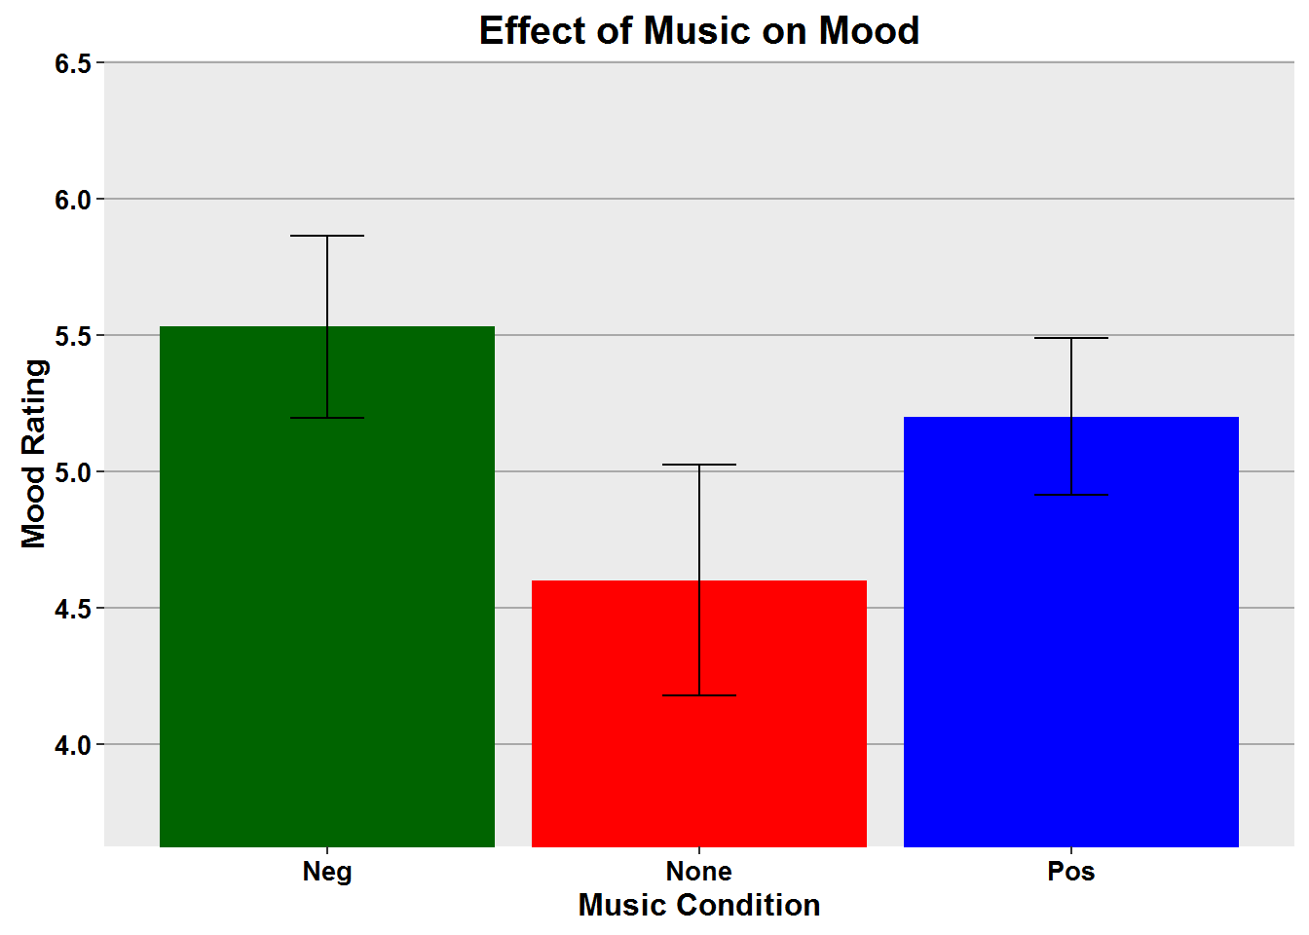

***Figure 1.*** *This graph shows the results of the one way ANOVA between the three conditions with regard to the mean of mood ratings for each group after hearing music or no music. No significant results were found here,* F(2,49) = 1.7, *p* = .187.

The ratings for the data regarding mood scores were translated to a score of 1 being the lowest, most negative mood, and 7 being the most positive. The negative music condition had the best mood scores overall, followed by the positive music condition. The no music condition participants had the lowest mood scores.

Another one way ANOVA was done for the average number of words correctly identified in each condition (see Figure 2). Based on these results, music did have an effect on the number of words recalled correctly, F(2,49) = 3.2, p = <.05. Participants in the negative music condition actually had the best overall recall of words, followed by the no music (neutral) condition participants. The participants in the positive condition had the least average recall of the three conditions.

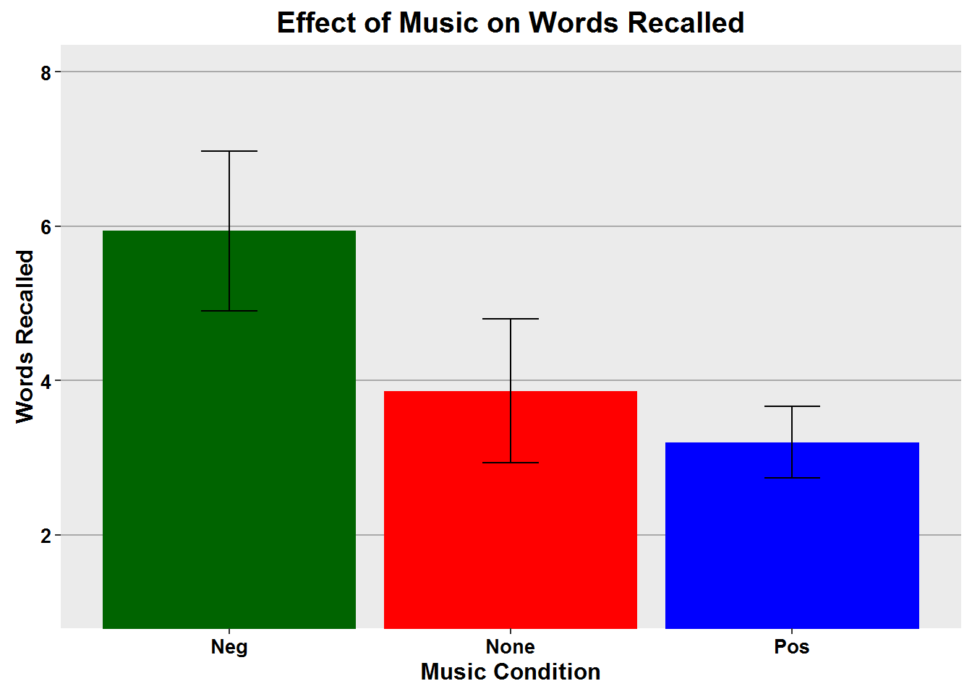

***Figure 2.*** *This graph shows the difference in the three conditions with regard to number of words recalled. The Negative music condition had the highest average recall,* F(2,49) = 3.2*, p =* <.05.

Follow up tests were run to determine between which two conditions the effect occurred. The results of a two tailed t-test indicated that the significant effect was between the Negative and Positive conditions, t = 2.5, df = 35, p = 0.015.

**Discussion**

The significant difference in words recalled was between the Negative and Positive conditions, and the results were opposite of what was hypothesized with regard to the group having the highest rate of recall. Instead of the positive music condition having the highest mean recall, followed by the neutral condition having the next highest and the negative music condition recalling the least number of words as we suggested, the opposite occurred.

It may be that the music effects on mood and memory did not indicate a main effect in the direction we hypothesized for various reasons. One possibility is that the positive classical music selection in the positive music condition was distracting during the word presentation video. It is also possible that the negative music was interpreted as calming or peaceful, as it was more slowly paced than the positive selection. If so, it is likely that this could have aided in concentration rather than producing a negative mood. For our experiment, the no music condition could have been less distracting than the positive music, allowing participants to encode more effectively. It is also possible that those in the no music condition could have been listening to something else of their choosing in the background while viewing the words.

In the ANOVA examining mood as a function of the music condition, there was no significant effect. It was hypothesized that the positive music condition would have the highest average ratings, followed by the neutral condition and that the negative music condition would have the lowest mood scores. If a mood rating was done prior to and after the music/no music presentation of words, this could have given additional insight into what the music conditions may have done to alter mood as compared to the no music condition.

One weakness of the study was that it was conducted via Facebook, an environment that is accessed heavily with cell phones. The SurveyMonkey site where the data were gathered asked participants to follow a link to the YouTube videos and those links did not work on cell phones or iPads, or (as we came to find out after a week into the experiment) with use of the Chrome browser. Based upon the way the survey portion of the experiment was set up, once a person continued on in SurveyMonkey without having watched the YouTube video there was no way to go back. In addition, each computer (IP address) could only be used to access the experiment once, so that the same person could not make multiple attempts. Therefore, when a person attempted to participate but was unsuccessful, there was no second chance. There was also the issue that once a person got to the end and saw the surprise recall task, they could not then go try again to do the experiment and watch the YouTube video of the words. The knowledge that they would be asked to recall the words would give them an unfair advantage and greater memory performance. It was possiblethat people either just clicked on the link to the survey before even reading the directions not to use cell phones, or they thought they could try it anyway.

Data from twenty-nine participants were excluded from the analyses. Data were excluded when participants never saw a video with words. Data were also excluded for those who should have heard music but did not, or said that they heard music when they should not have (based upon the month they were born and which condition that placed them in).  Incomplete responses were also excluded in which the respondent just stopped answering question somewhere in the process. There were 17 responses in the Negative condition, 15 responses in the None (neutral) condition, 20 responses for the Positive condition,

It is possible that if the experiment was conducted in a laboratory setting where the environment was controlled, results could have been different. All of the experiments mentioned previously in this paper by other researchers were conducted in a laboratory. If an experiment was conducted in a laboratory we could be sure that participants were using the correct equipment to access the experiment. It is impossible to know what was going on with the participants during their time of accessing the experiment. There is no way to know whether they watched the video and engaged in other activities before they completed the experiments. It is possible participants took several hours to go back to the SurveyMonkey site to complete the experiment after the YouTube video, as it was not timed. It may have been helpful to ascertain what participants were engaged in prior to the experiment, if they were distracted by anything during the experiment, or if they completed it all at once without gaps between tasks. A longer musical sample could have also possibly lead to different results. The portion of the experiment in which subjects viewed the words onscreen was less than two minutes so the music sample was fairly brief, more so than the experiments done by other researchers that were mentioned. It could be that there needs to be a longer exposure to music (or silence) to have an effect of condition upon mood. It is recommended that if this type of experiment is pursued again that the subjects participate while in a more controlled environment and to increase the sample size.

**Summary**

In previous experiments, there has been an apparent effect of music on mood and on performance that would indicate memory is enhanced by positive mood. In this experiment, we attempted to determine if there was an effect of positive music or negative music in a word recall task, with a control group who heard no music. Data gathered from the participants showed no significant effect of mood between the three conditions. The participants in the negative condition had the best recall of words, followed by the neutral condition and then the positive condition.

References

Balch, W. R., Myers, D. M., & Papotto, C. (1999). Dimensions of mood in mood-dependent memory. *Journal of Experimental Psychology: Learning, Memory, and Cognition, 25*(1), 70-83. doi: 10.1037/0278-7393.25.1.70

Houston, D., & Haddock, G. (2007). On auditing auditory information: The influence of mood on memory for music. *Psychology of Music, 35,* 201-212. doi: 10.1177/0305735607070303

Palmiero, M., Nori, R., Rogolino, C., D’Amico, S., & Piccardi, L. (2015). Situated navigational working memory: The role of positive mood. *Cognitive Processing, 16*, 327-330. doi: 10.1007/s10339-015-0670-4

Salimpoor, V.N., Benovoy, M., Larcher, K., Dagher, A., & Zatorre, R.J. (2011). Anatomically distinct dopamine release during anticipating and experience of peak emotion to music. *Nature Neuroscience*, doi: 10.1038/nn.2726

Appendix A

Word List

Words were presented in this order for two seconds each, with a one-second delay:

Chair   Tank   Screen   Candle   Riders   Office   Last   Wood   Eye   Free   Big   Ink

Follow  Lamp  Pick  Legs  Will   Veil   Tooth   Frame   Bottom   Thread   Door   Touch  Road

Appendix B

Mathematical Computations

Math problems presented in the following order:

1. 8 + 6 = 14
2. 32 - 7 = 25
3. 9 x 4 = 36
4. 20 / 5 = 4
5. The American flag has 6 white stripes, 7 red stripes, and 50 stars. How many stars and stripes are there altogether?